VASA® Floor C200 Floor Leveling Mortar
Technical Data Sheet

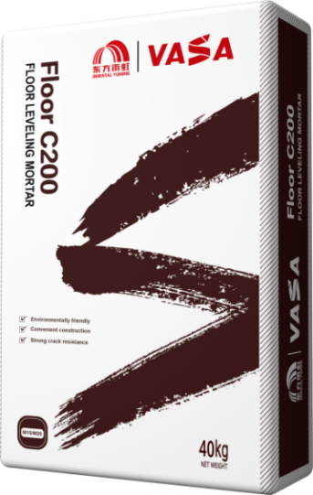
DESCRIPTION
VASA Floor C200 Floor Leveling Mortar is formulated with ordinary Portland cement as an inorganic binder, precisely graded sand as the aggregate, and a mix of functional additives. This product is ready to use after mixing with water and offers excellent crack resistance, easy application, and environmentally friendly features.

WHERE TO USE
Floor leveling projects where the thickness exceeds 10mm.

FEATURES AND BENEFITS
- High crack resistance
- Easy application
- Environmentally friendly

PRODUCT INFORMATION
This product complies with the DS standards in GB/T25181-2019 "Premixed Mortar." Main indicators are as follows:
NO. | ITEM | Technical indicator
1 | Appearance | Uniform,without lumps
2 | Water retention rate ≥ | 88%
3 | Setting time | 3-9 h
4 | 2h consistency loss rate≤ | 30%
5 | Compressive strength ≥ | 20MPa
Note:Compressive strength depends on the actual grade of supply.

APPLICATION PROCEDURE
Construction Tools
Mortar mixer, scraper, spatula, etc
Construction Process
- Substrate Treatment
The surface should be clean and solid. Remove any dust, grease, particles, or other loose materials that may affect adhesion. The surface should be moistened before applying the leveling mortar, and the application should begin when the surface is free of visible water. For surfaces with low strength or high absorbency, apply two coats of VASA PMC-500 primer before proceeding. For smooth surfaces, roughen or create a bonding texture.

- Level Marking
Use a level to mark the standard height and design thickness on walls and columns.

Plaster control points around the wall according to the leveling control line, , the size of the control points are generally 50x50mm, the horizontal and vertical spacing is 1.5-2.0 meters. Create control points around the walls with leveling mortar (VASA Floor C200) to guide the application.

- Mortar Mixing
Adjust the water addition based on the product certificate and specific requirements. Add water first, then slowly add the powder while mixing. Mix until the mortar is uniform and free of lumps, then allow it to stand for 3-5 minutes before mixing again for 15-30 seconds. The mortar is now ready to use.

- Leveling Application
Spread the mortar evenly over the floor surface, ensuring the thickness is slightly higher than the control points by 1-2mm. Use a screed to level the mortar, following the height of the control points. Compaction and smoothing must be completed before the mortar sets. The minimum application thickness should not be less than 10mm. For sloped areas, follow the design specifications.

- Cleaning and Curing
After the mortar sets and hardens, maintain moisture by curing for at least 7 days.

TECHNICAL INFORMATION
Packing Specification | 40kg/bulk
Character | Gray powder
Mixing Ratio | Refer to the product certificate
Shelf Life | 3 months when stored in a cool, dry place with unopened packaging.
Executive Standard | GB/T25181-2019 "Premixed Mortar" DS
Workable Time | 2h
Construction Consumption | 1.7-2.0kg/m²/mm, depending on surface conditions and application methods
Application Environment | 5-35°C, avoid high temperatures, frost, direct sunlight, wind, or rain during outdoor construction

TRANSPORT AND STORAGE
- For storage and transportation, avoid exposure to rain and physical impact to prevent damage to the packaging.
- Store in a cool, dry warehouse to prevent moisture exposure and avoid contact with water.
- Under normal transport and storage conditions, the unopened product has a shelf life of 3 months.

CAUTIONS
- Avoid temperatures below 5°C and above 35°C during application.
- Store and transport the product to prevent exposure to rain and moisture. Do not use if the product has clumped due to moisture.
- Do not mix with other products.
- Adjust the water addition according to the application method, and use the mixed mortar within 2 hours. Do not add water to hardened mortar.

SAFETY INSTRUCTIONS
This product contains alkaline components, which may cause irritation to the eyes and skin. Wear protective gear during application. In case of eye contact, rinse immediately with water and seek medical attention.

REMINDER
The stretch wrap and bottom wooden pallet provided at the factory will better protect the product from water, dust, and moisture, as well as protect the packaging. Please do not damage them before use! (Stretch wrap and wooden pallets are not provided for small quantities).

WARNING
The technical information and recommendations presented in this report are founded on our utmost knowledge and expertise. However, it's important to recognize that all the aforementioned details serve as guidance and should be validated through extensive real-world application. As such, individuals intending to utilize the product must conduct thorough assessments of its compatibility with the specific intended use. It is paramount to emphasize that the user assumes sole accountability for any ramifications arising from the product's utilization.

LEGAL NOTICE
The information within this Technical Data Sheet ("TDS") can be transferred to another document relevant to the project. However, the resulting document must not supersede or substitute the requirements specified in the current TDS during the installation of VASA products. The latest version of the TDS is available for download from our website www.vasa.top.

ANY MODIFICATION TO THE TEXT OR REQUIREMENTS INCLUDED OR DERIVED FROM THIS TDS RELEASES VASA FROM LIABILITY.

